**Experiment Title 1**

**Student Name: Husanpreet Kaur UID: 20BCS9512**

**Branch: BE-CSE Section/Group: 20BCS-DM-714/A**

**Semester: 6 Subject Code: 20CSP-376**

**Subject Name: Data Mining Lab Date of Performance: 24-02-2023**

1. **Aim/Overview of the practical:** Demonstration of preprocessing on .arff file using R Programming.
2. **Tools used:** RStudio and RWeka
3. **Code:**

library("RWeka")

setwd("C:\\Users\\hp\\Documents\\DATA MINING CODES\\EXPERIMENT 1")

getwd()

#Creation Of Data Frame

rating<- 1:4

animal<- c('Cat','Dog','Fish','Hen')

country<- c('India','Australia','USA','Japan')

avgerage_sleep_hours<- c(4,5,6,7)

name<- c("Chirag","Bither","Shivam")

#Make sure to set string as factors to false, so that string values are stored as characters and not as vectors.

super_sleepers<- data.frame(rating, animal, country, avgerage_sleep_hours, stringsAsFactors = FALSE)

print (super_sleepers)

print (class(super_sleepers))

print (str(super_sleepers))

write.arff (super_sleepers,file("super_sleepers.arff"))

N=read.arff ("super_sleepers.arff")

print(N)

print(head(N,2))

names(N)

N["animal"]

1. **Output:**

RStudio:

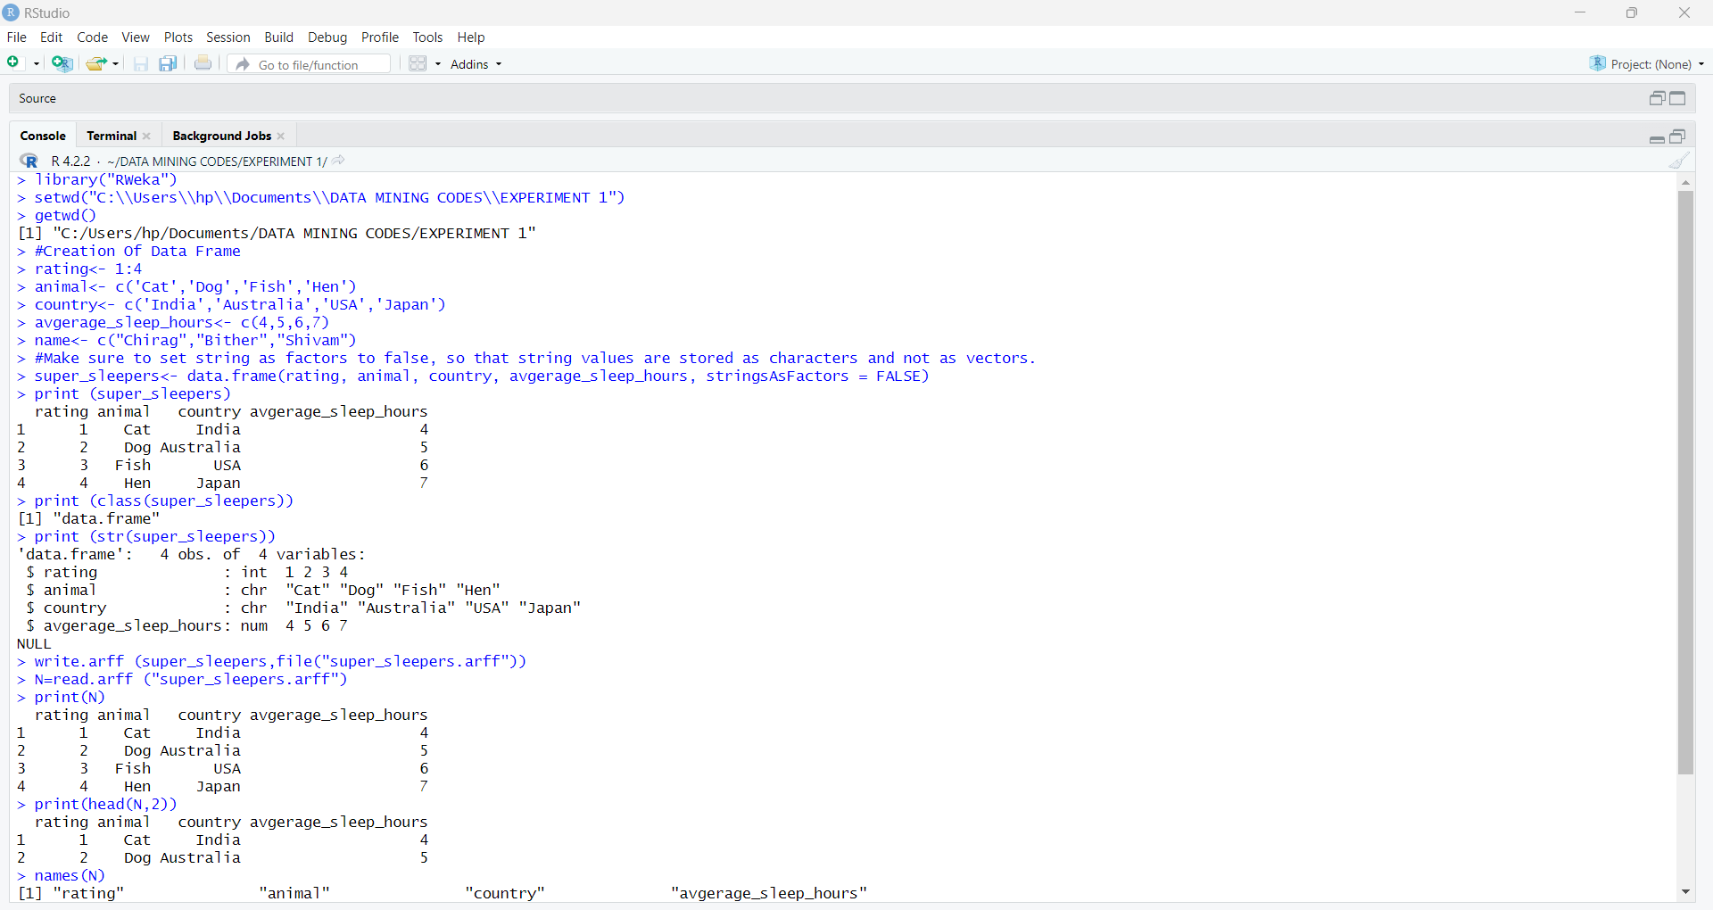



Files:

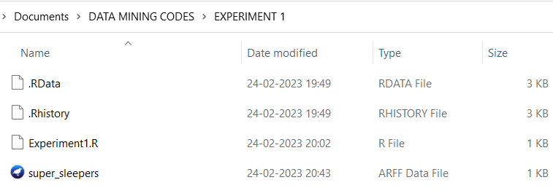

Weka:

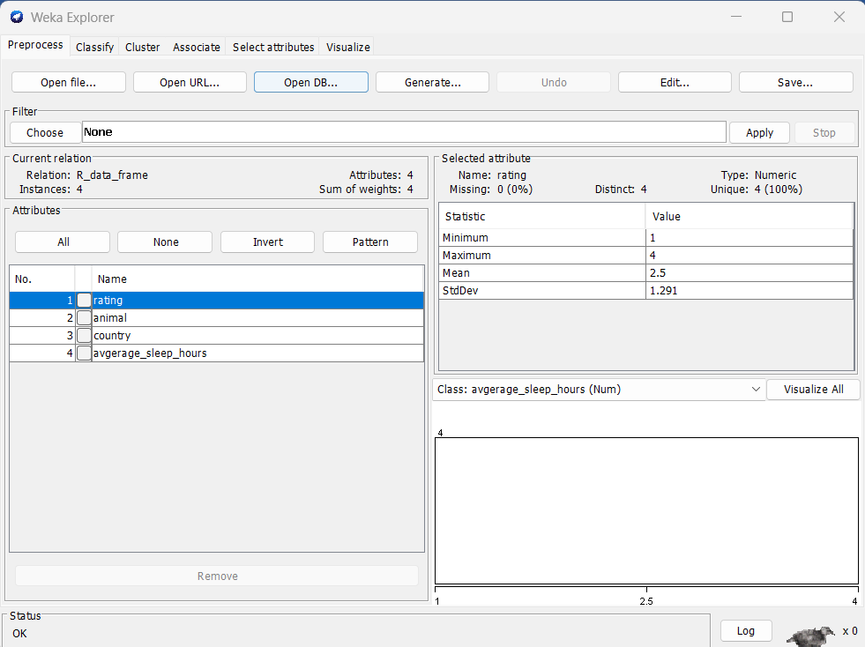

1. **Observation:**

* Learnt how to use R and create a file in Rstudio.
* Learnt how to import files in weka.
* Learnt basics of R language.
* Learnt about different methods like setwd() and getwd().
* Learnt how to use library function and how to install packages.